A000-Afr-Burkina Faso-Toussian-Mask

NK1087

Toussian Mask

Origin: Burkina Faso  
Size : 29.921 inches x 15.354 inches  
Weight: 6.31 pounds  
Material: wood

Case no. 6

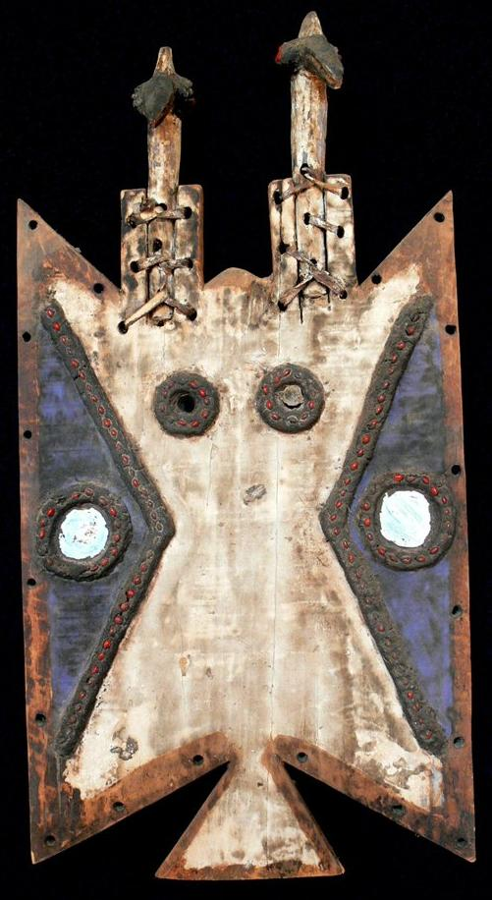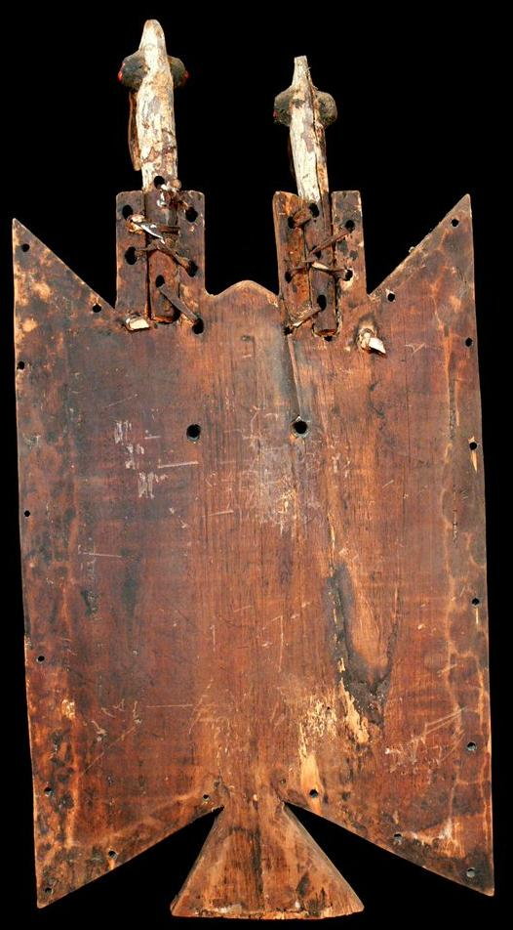

Fig. 1. Toussian Mask, Burkina Faso. Atlantika Collection

The Toussian (Tusyan) live in the extreme south-western Burkina Faso, have a relatively small, non homogeneous population of about 22,000 according to data collected by C. Roy in his 1987 book *Art of the Upper Volta Rivers*. They share much of their cultural life with their neighbors the Senufo, the Turka and Bobo and speak a very similar language.

This Toussian mask is from the region BoBo Dioulasso in Burkina Faso. Toussian masks are called Loniake and are simple planks that have been joined to make a flat surface that is carved in shallow relief on the front of the mask to define the area that is painted and through which holes in the middle are carved to allow the wearer to see through. A row of holes along the all edges are drilled to attach a fringe made of raffia (grasses). In fact, when the masks are danced the dancer is nude and his only cover are the grasses that cover his lower body.

They are carved by blacksmiths in secrecy and women and children are forbidden from seeing their manufacture. Toussian mask ceremonies regulate the life of the community such as blessing the grain prior to sowing, circumcision rites of young boys as well as instruction in their duties as adults in the village and in religious training. Masks are also employed in the funeral ceremonies of elders which lasts three days, after which the deceased's family is designated to keep it for a year. Each male initiate will keep his own mask after he has been initiated and each mask is given a secret name. They were quite often used as divination objects and are and called upon to predict events and ask for guidance by villagers.

The mask would have a bird’s beak (or, in this mask two carved bird’s heads and beaks) attached to the top. The surface is decorated with a base coat of kaolin and other pigments, mirrors and small red seeds set into beeswax in geometrical patterns. This is an old. well-used example of a Loniake mask.

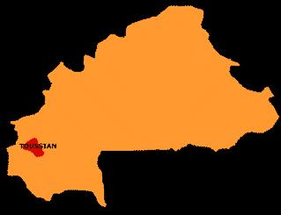

References:

[Manega Museum](http://translate.googleusercontent.com/translate_c?depth=1&hl=en&prev=/search%3Fq%3DToussian%26hl%3Den%26lr%3D%26safe%3Doff%26as_qdr%3Dall%26biw%3D1920%26bih%3D1044%26prmd%3Dimvns&rurl=translate.google.ca&sl=fr&u=http://www.musee-manega.bf/&usg=ALkJrhjEtmkMSN7QE_zQX_THOqvGRc8wdQ)

Roy, Chistopher D.and Françoise Chaffin. 1987. *Art of the Upper Volta Rivers.* Meudon, France : A. et F. Chaffin.

